Subject: Get a clear picture of your retirement income—in just minutes

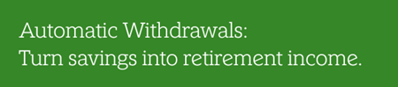
You’ve been working hard to build your workplace savings. Now it’s time to see how that savings can become steady income in retirement. The Automatic Withdrawals tool helps you explore your options and shows you how your savings can become reliable income.
With Automatic Withdrawals you can learn:
- How much you might receive
- How long your money could last
- What the estimated remaining balance might be
If you’re retirement age, Automatic Withdrawals lets you schedule withdrawals from your workplace retirement accounts to your bank account—creating a predictable paycheck tailored to your retirement goals.
Explore the tool to see what works best for you.

The NetBenefits® app gives you more ways to access and manage your employee benefits. Download now or open the app.

App Store is a registered service mark of Apple Inc. Google Play is a trademark of Google LLC.
Privacy policy | Terms of use

Investing involves risk, including risk of loss.
The information in this email is intended solely for the attention and use of the named addressee. This message or any part thereof must not be disclosed, copied, distributed, or retained by any person without authorization of the addressee.
Please do not respond to this email. This mailbox is not monitored and you will not receive a response.
NetBenefits, Fidelity, and the Fidelity Investments logo are registered service marks of FMR LLC.
Fidelity Brokerage Services LLC, Member NYSE, SIPC, 900 Salem Street, Smithfield, RI 02917
© 2026 FMR LLC. All rights reserved.
1243465.1.0

